Avinashilingam Institute for Home Science & Higher Education for Women
IIC ID-IC201811341
Institution Innovation Council
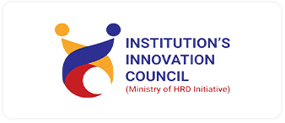
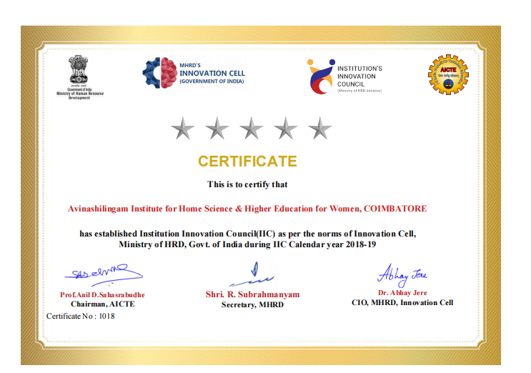
MHRD’S Institution Innovation Council was launched on 21st November 2018 in AICTE Headquarters, New Delhi.

